**Question-3:**

**a.** Differentiate between DROP and TRUNCATE commands of SQL with suitable examples.

**4 Marks**

**c.** Discuss the purpose of GROUP BY and HAVING clauses in SQL with suitable examples. **5 Marks**

**Question-4:**

**a.** Consider the table Product (pid, pname, price, category, manufacturer) and give the query to generate the below-given reports

i) Product name that has the maximum price

ii) Product name who have a minimum price

iii) The average price of all products

iv) The number of products in the company

v) Specify the various category in the company  **5 Marks**

**b.** Develop a relation Employee as below given specification and constraints.

i) Make sure ID range is between 1000 and 4000

ii) Create the FK constraint as on deleting any department the emp table id should change to Null **5 Marks**

**c.**

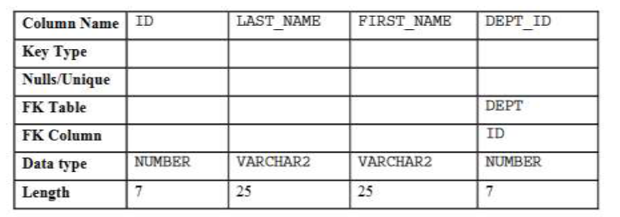

Write a suitable query to perform the following actions.

i)Modify the EMP table to allow for longer employee last names of size 50

ii) Confirm your modification. **4 Marks**

**Question-5:**

|  |  |
| --- | --- |
| **a.** Give all the correct query options from the list below  i.) create table EMPLOYEES (empno number,name varchar2(50) not null,job varchar2(50),manager number, hiredate date,salary number(7,2),commission number(7,2),deptno number,constraint pk_employees primary key (empno),constraint fk_employees_deptno foreign key (deptno) references DEPARTMENTS (deptno));  ii.) create table EMPLOYEES (empno numbers,name varchar2(50) not null,job varchar2(50),manager numbers, hiredate date,salary numbers(7,2),commission numbers(7,2),deptno numbers,constraint pk_employees primary key (empno),constraint fk_employees_deptno foreign key (deptno) references DEPARTMENTS (deptno));  iii.) create table EMPLOYEE (empno number,name varchar2(50) not null,job varchar2(50),manager number, hiredate date,salary number(7,2),commission number(7,2),deptno number,constraint pk_employees primary key (empno),constraint fk_employees_deptno foreign key (deptno) references DEPARTMENTS (deptno));  iv.) insert into EMPLOYEES (empno, name, job, salary, deptno) values (4101,'Sam Smith','Programmer',5000,4001 );  v.) insert into EMPLOYEES (empno, name, job, salary, deptno) values (4101,Sam Smith,Programmer,5000,4001 );  vi.) create table student(ID char(4) primary key,Fname varchar2(10),deptID char(4));  vii.) create table student(ID char(4),Fname varchar2(10),deptID char(4),constraint primary key (ID),foreign key (deptID) references dept(deptID));  viii.) select dept_no,max(salary) from employess GROUP BY dept_no HAVING max(salary)>10000;  ix.) select deptno,max(salary) from employess GROUP BY deptno HAVING max(salary)>10000; |  |

**4.5 Marks**

**b.**

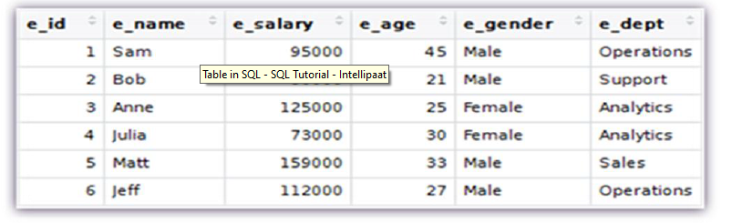

The list of queries is

i.) INSERT

ii) CREATE

iii.) ALTER

iv.) DELETE

v.) REMOVE

vi.) UPDATE

vii.) DROP

**3.5 Marks**

**c.**

Give the answers for the below-given functions

a. ROUND(56.678,2)

b. MOD(3401,100)

c. FLOOR(2.83)

**3 Marks**

**d.**

Write a join query to create a view with the below attributes and table names as given below.

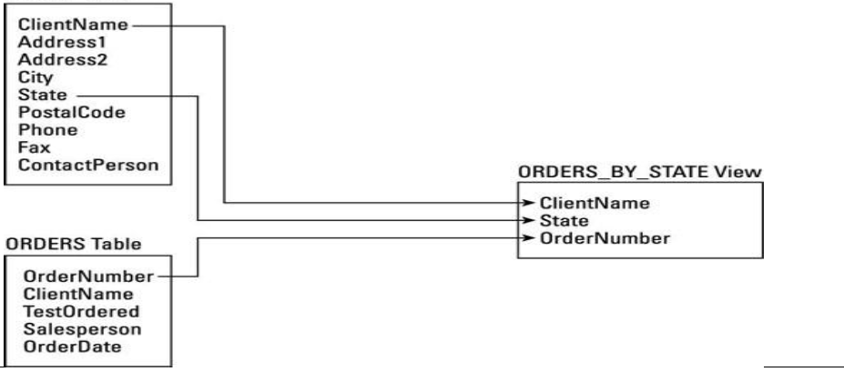

**3 Marks**

**------------------------------------------------------------------------------------------------------------------------------------**